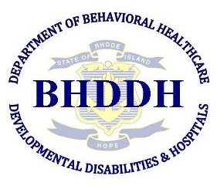
Regional Prevention Task Forces (RPTF) Meeting
March 2, 2017 9:00am-11:00am
BHDDH
14 Harrington Road- Barry Hall
2nd floor Conference Room 226
AGENDA
___________________________________________________________________
Meeting Goals- Information sharing update from providers on goals and timeline. Presentation. Discussion on training needs, evaluation and other questions.

Meeting Agenda
- Welcome & Introductions
- Review minutes
- BHDDH Updates
  - Reviewing Tasks and Timeline
  - Mosaix IMPACT and Data Entry
  - Other BHDDH Updates
- United States Attorney’s Office United States Attorney
  - Peter Neronha and David Neill
- URI Cancer Prevention Research Center
  - RI Student Survey update
- RPTF Communities Updates
  - Brief Updates and Information Sharing
- RI Prevention Resource Center Updates
- Regional Transition Tool Update
- Training Needs
- Upcoming Trainings
- Provider Portal
- Evaluation
- Announcements or Other Emerging Issues
  - Cultural Competency: A Process Versus a Destination (Training) March 6, 2017 9:00 am - 12:00 pm. Register: https://goo.gl/forms/AMqikX0dsZod4fH92
  - Governor’s Council Meeting March 14, 2017 1:00 pm- 3:00 pm HPE 301 Metro Ctr. Blvd. Warwick Room 203
  - Parenting Matters Conference March 25, 2017 9:00 am – 1:00 pm. Register: https://www.bradleyhospital.org/parenting-matters-registration-information
  - Prevention Advisory Committee Meeting March 27, 2017 1:00 pm -3:00 pm BHDDH room 126
  - RISAS's 30th Anniversary Conference on Youth Drug Trends March 31, 2017 9:00 am - 12:00 pm
Register: http://www.risas.org/poc/view_doc.php?type=doc&id=59778

Next Meeting: May 3rd (Barry Hall room 226 from 9-11am)

