**East Bay Parent Survey 2019**

This survey is being administered to parents throughout our region to help direct activities designed

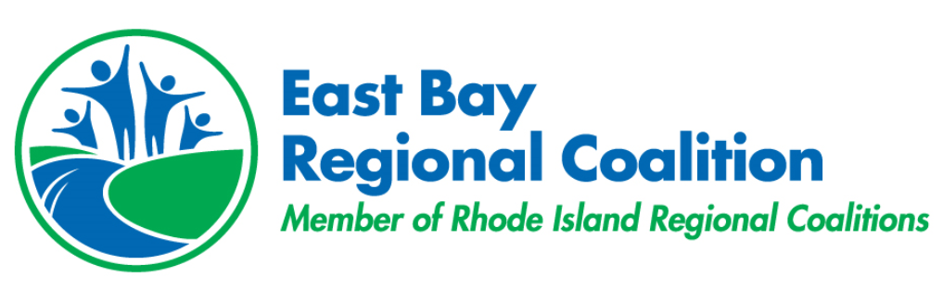to promote healthy communities. Thank you for your participation.



|  |
| --- |
| **1.** I am (circle one): **Male Female Non-binary/third gender Prefer not to say** |
| **2.** My child(ren) is/are in the following grade(s) (circle all that apply):    **5th or younger 6th 7th 8th 9th 10th 11th 12th Older than 12th** |

*Note: when answering questions about a particular child, please answer for the child for which you are attending this school event, or the one with the birth date closest to today's date (if you have multiple children in this school)

**3. What school does this child attend? __________________________**

**4.** People may have different beliefs about addiction to substances.

**Please indicate your opinion about the following statements related to addiction:**

|  |  |  |  |  |  |
| --- | --- | --- | --- | --- | --- |
|  | **Strongly**  **Disagree** | **Disagree** | **Neither**  **Disagree**  **Nor Agree** | **Agree** | **Strongly Agree** |
| Addiction to substances is primarily a moral problem |  |  |  |  |  |
| Addiction to substances is primarily a spiritual deficit |  |  |  |  |  |
| Addiction to substances is primarily a character disorder |  |  |  |  |  |
| Addiction to substances is primarily poor willpower |  |  |  |  |  |

**5. Please circle any condition below that you think is a mental illness (circle all that apply):**

Depression Stress Bipolar Disorder Drug Addiction Anxiety

**6. Most people with mental health problems go to a healthcare professional to get help (choose one answer):**

Strongly Disagree Disagree Neither Agree/Disagree Agree Strongly Agree

**7. Large numbers of students in our region reported feeling stressed about school and life and several reported feeling sad or hopeless. Other warning signs for suicide include: not feeling like oneself, agitation, withdrawal, risky behaviours such as substance use, and a decrease in caring for oneself.**

|  |  |  |  |  |
| --- | --- | --- | --- | --- |
| **I feel confident that I can:** | **Strongly Disagree** | **Disagree** | **Agree** | **Strongly Agree** |
| Recognize the signs that someone may be dealing with a mental health problem or crisis? |  |  |  |  |
| Ask a person whether she/he is considering killing her/himself? |  |  |  |  |
| Offer a distressed person basic “first aid” level information, resources, and reassurance about mental health problems? |  |  |  |  |
| Assist a person who may be dealing with a mental health problem or crisis to seek professional help? |  |  |  |  |

**Please turn sheet over to complete survey**

**8. Marijuana should be legalized (choose one answer).** **Yes** **No**

**9.** Changes in state and federal legislation can impact how people feel about things.

**Please tell us how you feel about *youth* use of marijuana (choose one answer).**

|  |  |  |  |  |  |
| --- | --- | --- | --- | --- | --- |
|  | **Strongly Disagree** | **Disagree** | **Neither Disagree nor Agree** | **Agree** | **Strongly Agree** |
| Marijuana is harmful to youth. |  |  |  |  |  |

**10. How Often Do You… (choose one answer)**

|  |  |  |  |  |  |
| --- | --- | --- | --- | --- | --- |
| …ask with whom your teen is spending time? | **Never** | **Rarely** | **Some of the Time** | **Most of the Time** | **All of the Time** |
| …contact the parent of a home where your teen will visit? | **Never** | **Rarely** | **Some of the Time** | **Most of the Time** | **All of the Time** |
| …think teens risk harming themselves or others if they drink alcohol? | **Never** | **Rarely** | **Some of the Time** | **Most of the Time** | **All of the Time** |
| …think teenagers risk harming themselves or others if they use marijuana? | **Never** | **Rarely** | **Some of the Time** | **Most of the Time** | **All of the Time** |
| …think teenagers risk harming themselves or others if they use electronic cigarettes (Juuls)? | **Never** | **Rarely** | **Some of the Time** | **Most of the Time** | **All of the Time** |
| …discuss the harms of either using someone else’s prescription drugs, or giving prescription drugs to someone else? | **Never** | **Rarely** | **Some of the Time** | **Most of the Time** | **All of the Time** |

**11. Family Rules (choose one answer)**

|  |  |  |
| --- | --- | --- |
| My family has rules against teenagers drinking alcohol. | **True** | **False** |
| My family has rules against teens using electronic cigarettes, like Juuls | **True** | **False** |
| My family has rules against teens using marijuana | **True** | **False** |
| I have told my teen what would happen if they were caught breaking family substance use rules | **True** | **False** |

**12. Safe Storage (choose one answer, select N/A if you have none in your home)**

|  |  |  |  |
| --- | --- | --- | --- |
| All alcohol in our home is secured in a way that no teens can access it. | **True** | **False** | **N/A** |
| All marijuana in our home is secured in a way that no teens can access it. | **True** | **False** | **N/A** |
| All prescription medications in our home are secured in a way that no teens can access them. | **True** | **False** | **N/A** |

**13. Opioids (Choose one answer)**

|  |  |  |  |  |
| --- | --- | --- | --- | --- |
|  | **Very unlikely** | **Unlikely** | **Likely** | **Very likely** |
| If prescribed an opioid (ie. Percocet, Vicodin), how likely would you be to initiate a conversation with your healthcare provider about alternative forms of treatment? |  |  |  |  |
| If your child were prescribed an opioid (ie. Percocet, Vicodin), how likely would you be to initiate a conversation with their healthcare provider about alternative forms of treatment? |  |  |  |  |

**Please turn in your survey to enter our raffle for free prizes!**

The East Bay Regional Coalition was formed in 2017 when RI Department of Behavioral Health Developmental Disabilities and Hospitals created a new model for substance prevention in RI. The Regional Coalition supports the efforts of the local coalitions in Barrington, Bristol, East Providence, and Warren, while also providing a vehicle for collaborative strategies across the region related to prevention and health promotion across the lifespan.