Underage Drinking during COVID-19  Help teens make the best decisions  Alcohol purchases have increased across the U.S. by 22%. This increased supply at home, combined with ease of acquiring alcohol through delivery, and free time among teens who are isolated at home can put teens at risk of experimenting with alcohol.  Alcohol increases potential dangers to youth including damaging brain development, lifelong alcohol dependency, and susceptibility to COVID-19. You can help reduce the risks to teens by following these suggestions:  - Keep alcohol out of the house or locked up so that teens cannot access it.  - Keep a log of how much alcohol is in the house, so that if any goes missing you can be aware.  - Talk to your teens about the dangers of underage drinking. Establish rules about alcohol and enforce consequences.  - Talk to your teen about the importance of social distancing and to avoiding parties during the COVID-19 outbreak.  - Do not drink in front of teens, you are their role model. | Know how to keep your teen safe!  ────  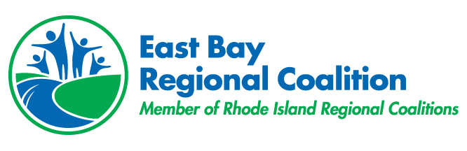  ────  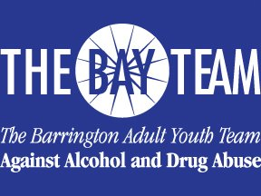  ────  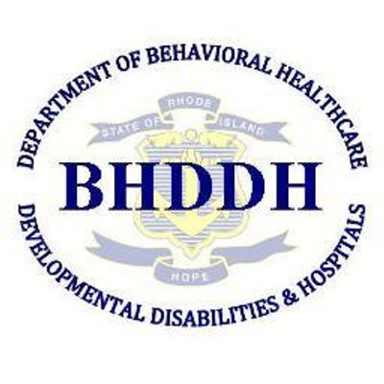  Easy Bay Regional Coalition  283 County Road  Barrington, RI 02806  401-247-1900 ext.316  www.riprevention.org

