11/10/2017
Rhode Island Department of Behavioral Healthcare, Developmental Disabilities and Hospitals
Additional Guidance on Entering Municipal Prevention Task Force Data into Mosaix IMPACT
A Companion Document for the Mosaix IMPACTSAPT User Guide Version 2

Table of Contents

Purpose 2
Structure and Content 2
Naming Conventions 3
Section 1 – Assess 3
Data Sources 3
Add Problem Behavior 4
My Needs Assessment 5
Section 2 – Capacity 6
Coalition 6
Manage Business/Partner Member 6
Manage Individual Members 6
Organization Meeting 6
Organization Subcommittee 7
Section 3 – Planning 8
Manage Strategic Plans 8
Identify Goals 8
Identify Objectives 9
Identify Program 10
Identify Activities 12
Identify Participants 12
Identify Recurring Groups 13
Manage Logic Model 15
Work Plan 15
Section 4 – Implement 16
Record Single Service 17
Record Recurring Service 19
Section 5 – Reporting 20
Non-Demographic Report: 20
Demographic Reports: 22
Section 6 – Frequently Asked Questions (FAQ’s) 24
Additional Instructions & Closing 26

Purpose
This document provides additional guidance on the entry of data related to the Municipal Prevention Task Forces in the IMPACT^{SAPT} Prevention Platform. This is meant to augment the existing User Guide version 1.0 and covers only that content specific to Municipal Prevention Task Forces data entry. This document will provide information on which screens and fields are required for MUNICIPAL PREVENTION TASK FORCES and which are not. In addition, examples of how to create specific entries for the MUNICIPAL PREVENTION TASK FORCE. The example provided is the fictional Anytown Prevention Coalition which is part of Region 9 (also fictional).

Structure and Content

IMPACT^{SAPT}

This document is arranged in the order of the IMPACT^{SAPT} modules. It features screen shots of the demonstration site and provides examples of different types of entries from the demo site. This guide also provides instruction on how to enter content for some fields. The screen shots featured in this guide will differ in title and content from those you will view during data entry.

The Module or screen names are also different as the screen will be titled “Create” as you enter data the first time, and then “Edit” if you change an entry, and, “View” if you are reviewing or searching for data previously entered. A red asterisk (*) denotes a required field and you will not be able to progress on the screen until that data is entered.

There are some fields and sections which are universally required across all funding streams while others are required only for some funding streams. In some cases, the entry from the screen shot is not actually a MUNICIPAL PREVENTION TASK FORCES example but provides the best illustration of the required field and format. These are screen shots of previously entered “dummy data” and generally displayed in the view (the paper icon) or edit (the pencil icon) screens and may not show all functions in the screen, especially the blue upload and save buttons. Don’t forget use the blue SAVE button any time you create or edit an entry!

Please refer to the IMPACT^{SAPT} User Guide version 1.0 for general entry instructions, such as how to create, save or edit entry of screens and fields within a given module. If you want to view a version the blank screen for creating an entry within a required field or screen, the IMPACT^{SAPT} User Guide is a better resource to provide that information.

Much of the content entered in the Assessment and Capacity Modules will only need to be entered one time. Within the Capacity Module, there will be updates when your coalition meets or if membership changes. The Planning Module is similar in the Goals, Objectives and Programs will remain stable excepting the entry of new cycles and new summary groups associated with programs.

Naming Conventions
Please use the following naming convention for all Municipal Prevention Task Forces entries for IMPACT goals, objectives, programs, groups (summary), recurring and single services to differentiate the MUNICIPAL PREVENTION TASK FORCES entries from other similar activities that may be funded by other sources. For example: Anytown Prevention Coalition.

Regional versus Municipal Entries

The MUNICIPAL PREVENTION TASK FORCES will be connected to the Regional Prevention Task Force (RPTF) with whom they are affiliated with the RPTF identified as a managing organization. This will facilitate the ability to pull data and/or run reports at either the municipal or regional level. Records will exist for both units. Regional entries will focus primarily on Goals, Objectives and Activities that are related to the Regional Prevention Task Force Scope of Work. Municipal entries will focus primarily on relating activities and recurring or single services to programs. Please note that there is a separate guidance document pertaining to entries for REGIONAL level activities.

Section 1 – Assess

Data Sources
Note: This section simply refers the reader to a set of data sources available for use in assessing community needs and resources. There’s no specific data entry required for this screen.

Add Problem Behavior
This is a required section for everyone including Municipal Prevention Task Forces. The Problem Behavior Title, Status and Organization fields are all required.

- The problem behavior should reflect the priority problem(s) from the REGIONAL PREVENTION TASK FORCE Strategic Plan. If the MUNICIPAL PREVENTION TASK FORCE has an additional problem behavior that is completely unique to them, they will need to create an entry. For this kind of record, the naming convention should reflect the name

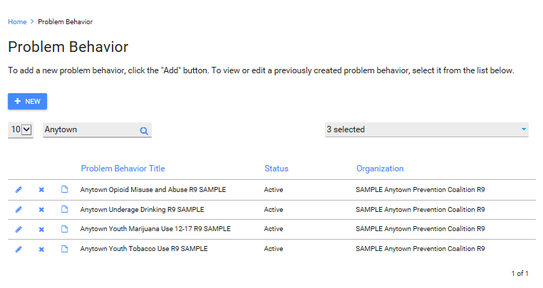

My Needs Assessment
This is a required section for MUNICIPAL PREVENTION TASK FORCES communities. You only need to enter the Regional Needs Assessment. The work of the partner municipalities will be captured in the workplan in the IMPLEMENT Module.
NOTE: If additional municipal needs assessments are completed during the funding period, prior needs assessment can be marked inactive.

There are a series of screen shots depicting entries over the next few pages.

- Target substance is a required field but the choices will populate from the priority problem location.
- Target age groups is a universally required field; but please also make sure to enter the Geographic Setting, Community Setting, Target Race, Target Age Groups, Grade Level Served, and Sub-Populations.
- You will need to enter the start and end date for the assessment. The start date may precede the submission of your strategic plan but cannot precede the start date for the problem behaviors. You can choose the end date.
- The problem behavior should pre-populate based on the entries in the Problem Behavior Section. You may select as many as you have included in your needs assessment. They will have to be active problem behaviors in order to select them.

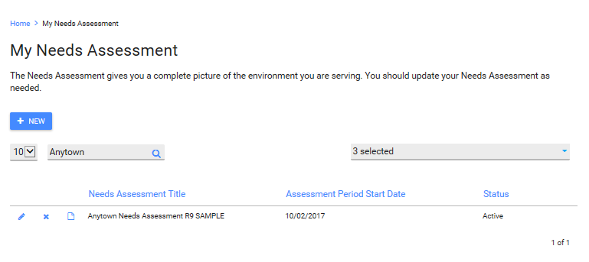
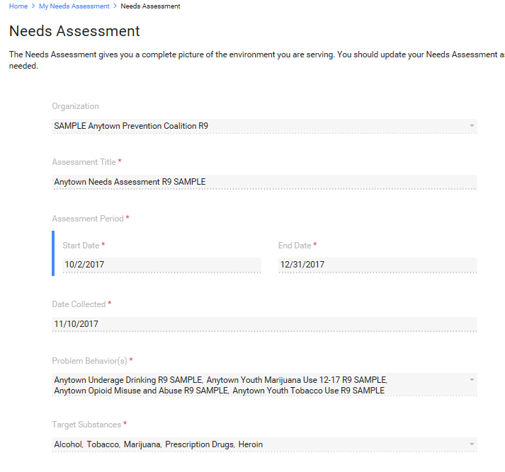
Screen shot from prior page continued below.

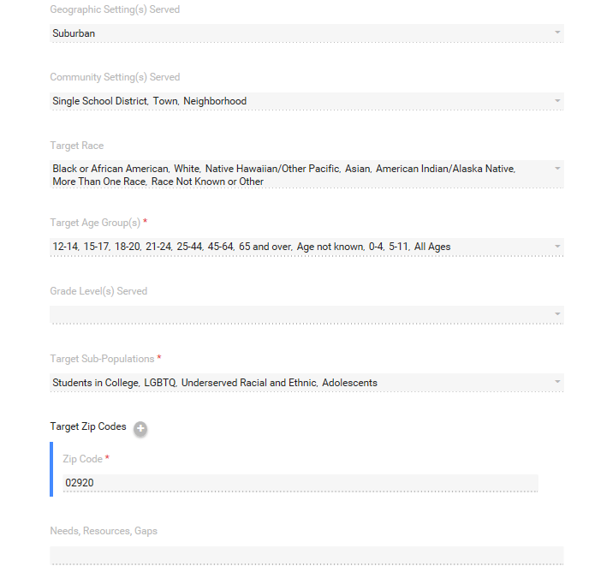

- Target Zip Codes, Target Risk Factors and Target Protective Factors are all required fields.
- Please enter all zip codes where you are implementing interventions or capacity building activities funded through the MUNICIPAL PREVENTION TASK FORCES. If the municipality has multiple zip codes they should all be entered here.
- Needs, Resources, Gaps and Findings of Epi Data are not required fields. These will be covered with the upload of the Assessment of Community Need.
Screen shot from prior page continued below.

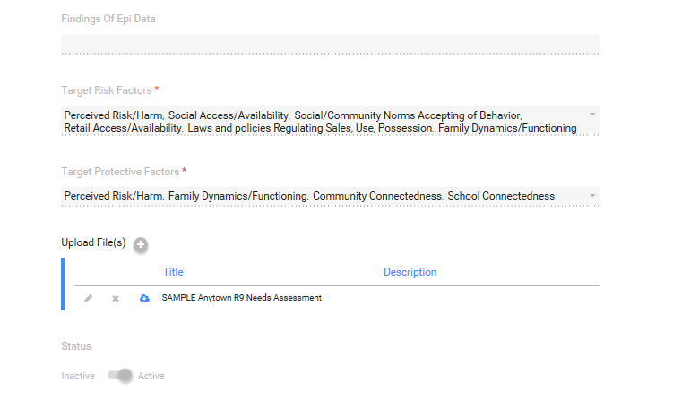
- The Target Risk Factors and Target Protective Factors are from a dropdown menu. Select all that are included in your logic model.
- Please make a copy of the Assessment of Community Need section of your MUNICIPAL PREVENTION TASK FORCES community strategic plan which covers Step 1 of the Strategic Prevention Framework (SPF) and upload it. You will need to create a title. If a separate needs assessment was done by independent contract that informed your needs assessment and is available for upload, you may also include it.
- You will need to click on Upload File (button will be blue initially, but then will turn gray as in this screen shot) Title is a required field – please use Region number in the naming convention (e.g., R 9 -Municipal Prevention Task Forces Needs Assessment 2017 to 2021) and the term Needs Assessment in the naming convention.
- Select the file from the Browse function, provide a brief description such as “Anytown Prevention Task Force- Needs Assessment 2017 to 2021.”
- Click upload and identify status (active for MUNICIPAL PREVENTION TASK FORCE). If a new needs assessment is added, please remember mark the prior entry as inactive and the new entry as active.
- Lastly, click SAVE. The save button should turn blue after the upload is completed, signaling that the entry should now be saved.

Section 2 – Capacity

Coalition
Manage Coalition is required field for MUNICIPAL PREVENTION TASK FORCES.

All contact related fields are required for MUNICIPAL PREVENTION TASK FORCES and although they are not displayed in the screen shot. The MUNICIPAL PREVENTION TASK FORCE Coordinator Grant Manager should be listed. This should be a one-time entry barring changes in leadership.
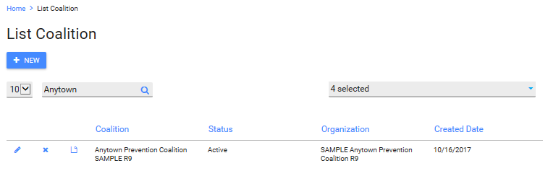

Manage Business/Partner Member
This is a required section for MUNICIPAL PREVENTION TASK FORCES.

This is where you would enter information for core sector representatives. You can have multiple individuals associated with a Business/Partner Member entry.
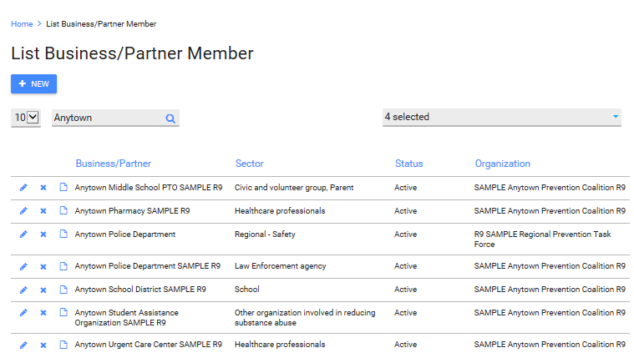
Below is the detailed entry for a business member.

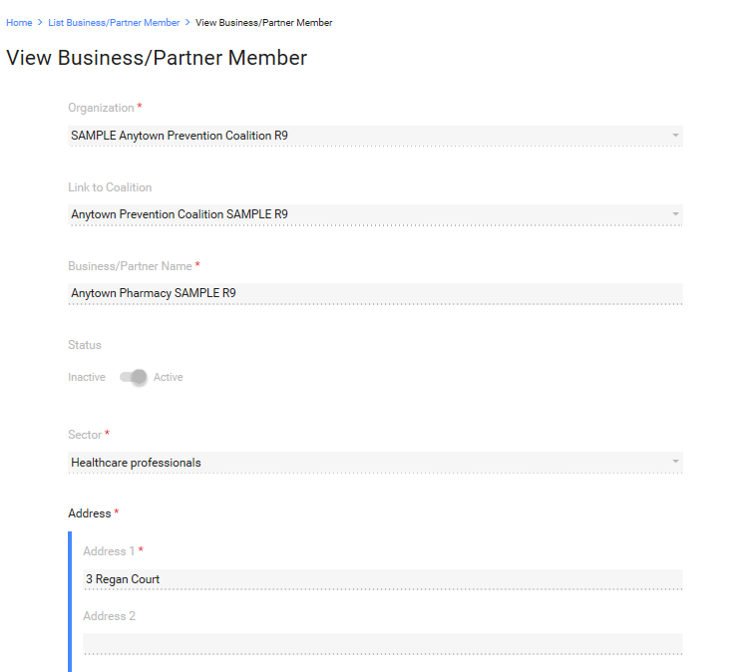
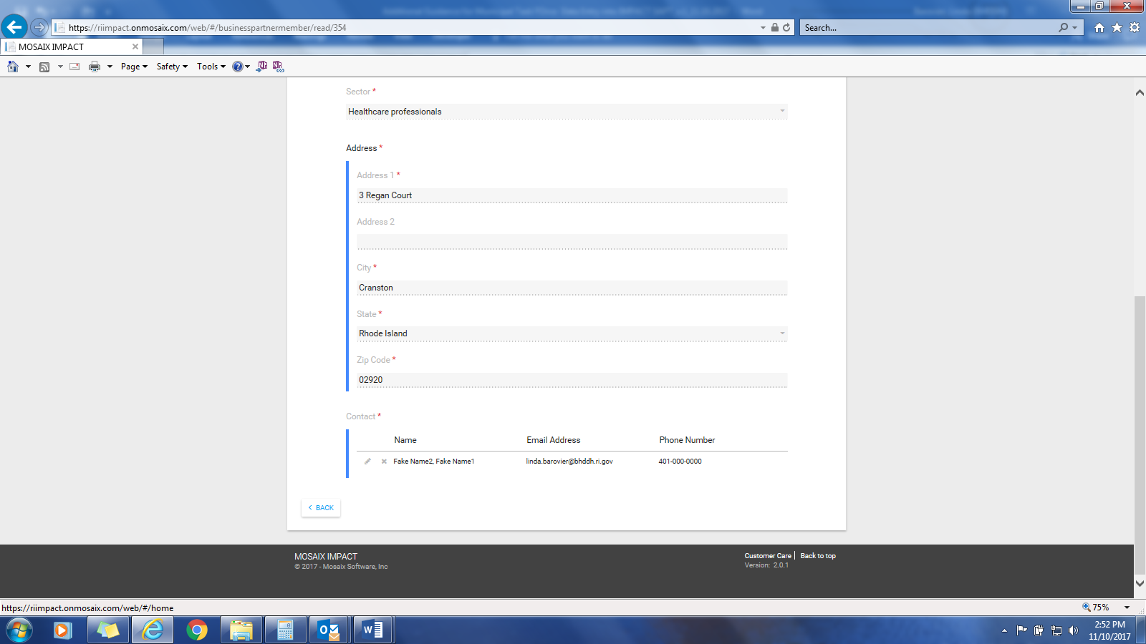

Manage Individual Members

This is a required section for both MUNICIPAL PREVENTION TASK FORCES s.
This is where you would enter information for individual representatives who aren’t affiliated with a specific sector. Remember to save entry at the end. No screen shot is provided, as it’s essentially the same as the Business/Partner screen and field.

Organization Meeting
This is a required section for MUNICIPAL PREVENTION TASK FORCES. PLEASE OBSERVE NAMING CONVENTIONS for meetings because both REGIONAL PREVENTION TASK FORCES and municipalities will have data inputted for their coalition/task force meetings.

Please note that this is essentially an archive for MUNICIPAL PREVENTION TASK FORCES meeting dates and minutes. It is not linked to anything else in IMPACT, isn’t included in any the counts of service codes and therefore doesn’t get captured in counts of activities related to the six (6) CSAP Prevention Strategies. Data will also need to be entered in the Plan>Program module to generate information on Community Based Process activities needed for Block Grant reporting.
Meeting title, date and duration are required fields. If you have a MUNICIPAL PREVENTION TASK FORCES subcommittee or workgroup, please be sure to include them too – you will create this in subsequent screen.

- This is where you will enter your coalition meetings and upload minutes
- You will click on the Attachment + to upload meeting minutes. Don’t forget to save after the upload before you exit the page!
- Once you’ve entered the individual and business/partner members and sub-committees, you will be able to select them as attendees.
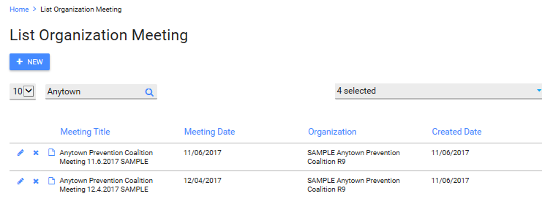
This screen should be updated after each coalition/task force meeting and the related minutes should be added.

Organization Subcommittee
This is a required screen for MUNICIPAL PREVENTION TASK FORCES if there are MUNICIPAL PREVENTION TASK FORCES or municipal TF related sub-committees.
The organization is pre-populated and the Subcommittee title is a required field. Even though it’s not a required field per se, please add the Business/Partner or Individual Members associated with the sub-committee. If the subcommittee is ad-hoc and no longer meets, select the inactive status.

There is no sample or screen shot for this screen.

Section 3 – Planning

Manage Strategic Plans
This is a NOT required field for MUNICIPAL PREVENTION TASK FORCES. The strategic plan is developed as a regional product and the municipality is not required to to create a separate strategic plan, just municipal work plans. However, some municipalities may opt to create a strategic plan. If a strategic plan exists for the municipality, it can be entered here. Because this is not required, no screen shot is provided.

- For initial entry, use the “+ New” button. Most of you will have one strategic plan but older strategic plans can be stored here as well.
- Enter the name of your strategic plan, start year and expiration year. Please insure that the naming convention from page 3 is used.
- You will need to use two steps – (1) use the blue UPLOAD button to upload the plan AND (2) the SAVE button to save the entire entry. The screen shot does not show these steps.

Identify Goals
This is a required field for MUNICIPAL PREVENTION TASK FORCES.
This list references the goal associated with the priority problem identified in the REGIONAL needs assessment process and is contained in the strategic plan and logic model. The goal usually has directionality associated with it (increase or decrease). It is typically a reduction in use of the targeted substance and will be something that will take the life time of the award, or longer, to accomplish. You will have to select from the REGIONAL goals. It will be a one-time entry.

- Please observe the naming convention noted on page 3 for this entry.
- If you selected two priority problems, you will need to create two goals because each priority has a different set of evidence based practices/policies/programs (EBPs) and activities associated with them.
- Later in this module, you will create objectives, programs and activities associated with your goal(s) from your logic model and strategic plan.
- Goals are longer term and so will remain in active status until the end of MUNICIPAL PREVENTION TASK FORCE’S funding. You will change the goal status from active to inactive during the last round of data entry for your contract period.

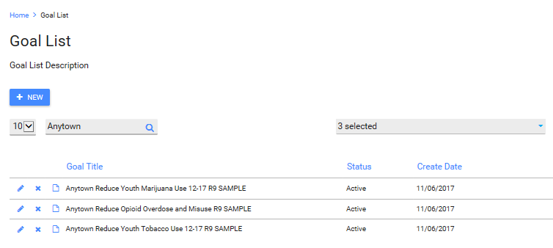

All fields in Goal Description, except Assessment Tools, are required for MUNICIPAL PREVENTION TASK FORCES. Please note that the screen shot does not show all fields populated.

- The goal title should reflect a reduction in the use of the target substance or target substances (e.g., underage drinking, youth marijuana use, opioid use, youth tobacco use or all, depending upon your strategic plan and the available resources).
- Goal start date should be when your plan was approved and/or when you started capacity building activities or implemented EBPs.
- Goal outcome descriptions should relate to reducing the prevalence of underage drinking, youth marijuana use or both based on your strategic plan.
- The RI Student Survey (RISS) is the tool we will use to measure progress towards the long term MUNICIPAL PREVENTION TASK FORCES goal of reducing the problem behaviors described earlier. A specific magnitude of change should be articulated based on your strategic plan and logic model.
- The progress indicator will be administration of the baseline data collection of RISS in Spring of 2016.
- The goal start date and progress indicators are the required fields for this screen, the rest will pre-populate based on prior entries. Nothing after progress indicators is required (e.g., assessment tools). A progress indicator for this example might be completion of X number of vendor/merchant education sessions.

he next screen shot shows more detail about the Goal and how to formulate specific entries for MUNICIPAL PREVENTION TASK FORCES. This entry show the entry related to the first goal on p.11.

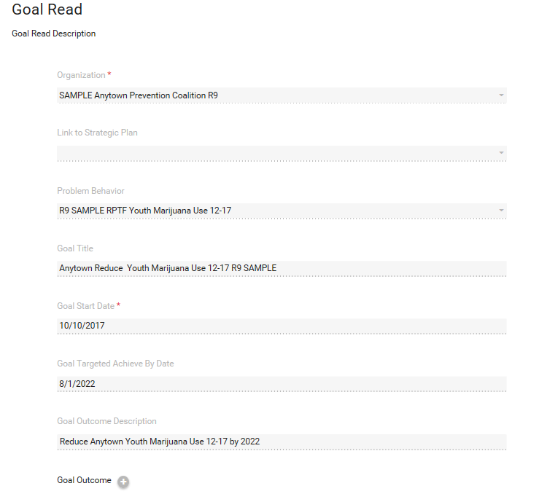

This screen shot omits progress indicators and goal status.

Identify Objectives

This is a required field for MUNICIPAL PREVENTION TASK FORCES.
Objectives should reflect efforts or activities that address a risk or protective factor associated with the Goal. Like the goal, where possible the objective should be expressed as a change in directionality. The OBJECTIVE must be created by the MUNICIPAL PREVENTION TASK FORCE. Unlike the GOAL, it is not prepopulated from the REGIONAL list.
- Each Objective will be linked to a goal. The Objective will relate back to the targeted risk or protective factors from your strategic plan and logic model. These are what you are targeting more directly with your EBPs.
- You will also have multiple objectives as you are targeting more than one risk or protective factor.
- The Objective Title doesn’t have to specify a magnitude of change as the next screen, Objective Detail, will cover it.
- The Objective can later be linked to multiple programs.

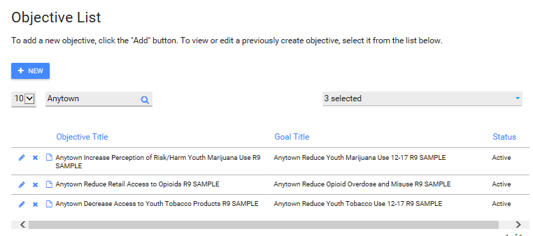

A sample objective record appears in the screen shot next page.

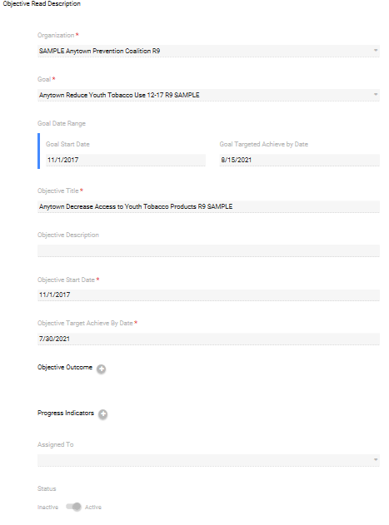

- This is the next level of the Objective Create/List screen. Objective title is a required field and should address a risk or protective factor associated with your plan and logic model. Please use the naming convention described on p.3.

- The sample on the prior page did not depict objective outcome(s) or progress indicators, although it is recommended that they be entered.

- You will have an outcome listed and objective for each risk or protective factor listed in your logic model.

- In the next screen, you will link programs or activities to the objective. Multiple programs or activities can be linked to an objective.

Identify Program

This is a required field for MUNICIPAL PREVENTION TASK FORCES.

- You will have to select a program type when you create the program initially. You will have to select a CSAP strategy targeted. It is very important that you select the proper strategy associated with the program.

- Programs funded under MUNICIPAL PREVENTION TASK FORCES will fall into different program types.

  - EVIDENCE BASED Programs-MUNICIPAL PREVENTION TASK FORCES s will capture evidence based practices such as school based curriculum or other multi-component interventions contained in SAMHSA’s National Registry of Effective Programs and Practices under the EVIDENCE BASED category. BHDDH staff or the Evidence Based Practices Workgroup will be able to assist in identifying if the program is evidence based.

  - ENVIRONMENTAL STRATEGIES-MUNICIPAL PREVENTION TASK FORCES s will capture environmental strategies such as use of social marketing, media literacy, media advocacy and policy or ordinance change, compliance checks, party patrols and other enforcement strategies.

  - LOCAL Programs - Each MUNICIPAL PREVENTION TASK FORCES will need to create at least one LOCAL
program with the following naming convention “{enter MUNICIPAL PREVENTION TASK FORCE name} Planning and Community Based Process.” This is necessary to capture Community Based Process activities undertaken by the task force and is where staff time in support of regional planning and service delivery coordination will get captured. Task Force Meetings and single services such as town halls and community forums are convened for the purposes of planning and obtaining input/feedback from the community regarding prevention priorities and emerging issues. This work is defined as Community Based Process by CSAP. Although you may enter information concerning Task Force meetings into the IMPACT^{SAPT} Capacity Module, it does not link that data to goals, objectives or programs. This data is needed for accurate Block Grant reporting. Other local programs may also be entered. Programs that don’t fit criteria for evidence based or an environmental strategy, will be treated as LOCAL.

- The Programs you enter should align with the names of the prevention interventions identified in your strategic plans and correspond with naming convention guidance from page 3. Some hypothetical examples include: “R9 Anytown Above the Influence; R9 Anytown Positive Action, R 9 Anytown Alcohol Compliance Checks, etc.”

The screen shot below depicts a number of program entries.

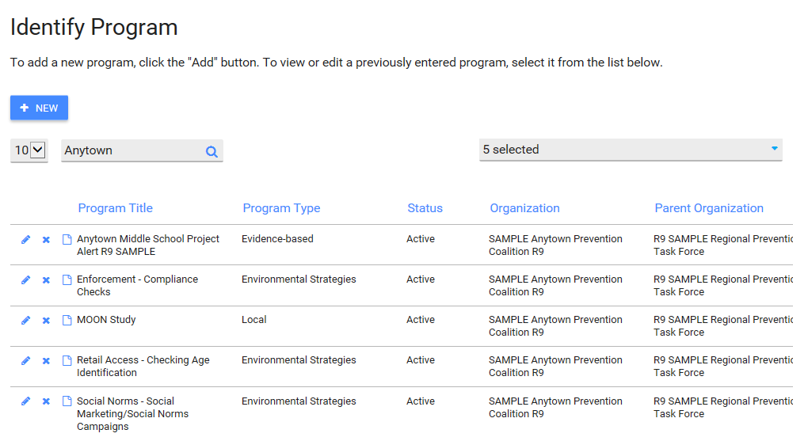

The screen shot next page depicts an entry for community based process and planning.

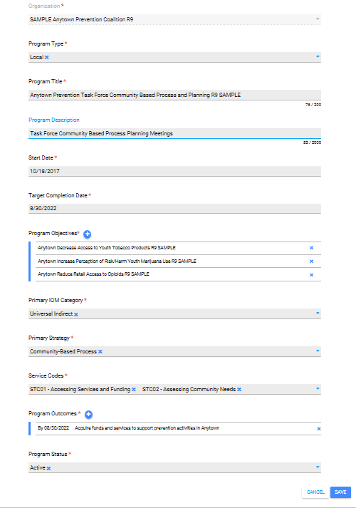

Identify Activities
This is a required field for MUNICIPAL PREVENTION TASK FORCES.
This section is for recording the types of activities you plan to carry out as part of your prevention intervention (i.e. Program). It is recommended that you create at least one activity for each Program. You do not need to create separate planned activities for multi-component interventions.

Your planned activity will then get linked to each of the actual activities or services you record under Implement/Recording Single of Recurring Services. Most services will be recurring.

This field will also be used to capture MUNICIPAL PREVENTION TASK FORCES performance measures related to increase reach and dose. More information on this can be found in the Frequently Asked Questions section.

In addition, there is a sheet that contains a list of service codes that are associated with CSAP strategies to assist in accurate data entry.

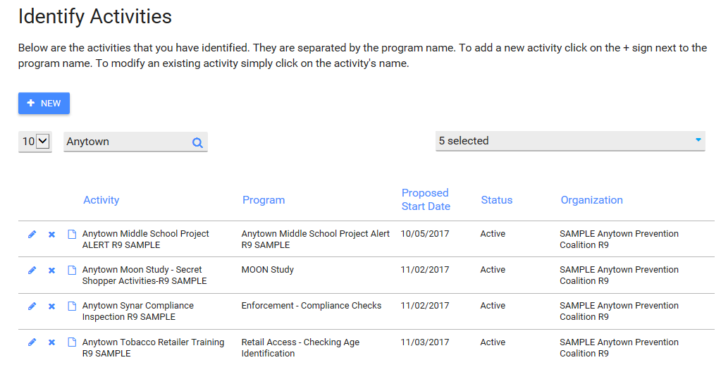

Activity detail - screen shot next page.
The series of screen shots on pages 20-21 how to capture work of the MUNICIPAL PREVENTION TASK FORCES in assessing needs and planning for delivery of prevention services within the region. This is the work of Community Based Process and a substantial part your work. a series of screen shots will capture activities related to various tasks contained in the Scope of Work for the MUNICIPAL PREVENTION TASK FORCES contracts.

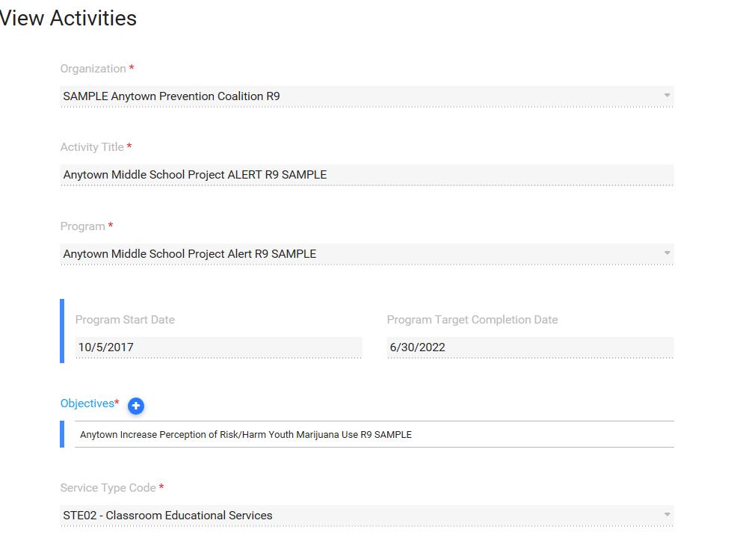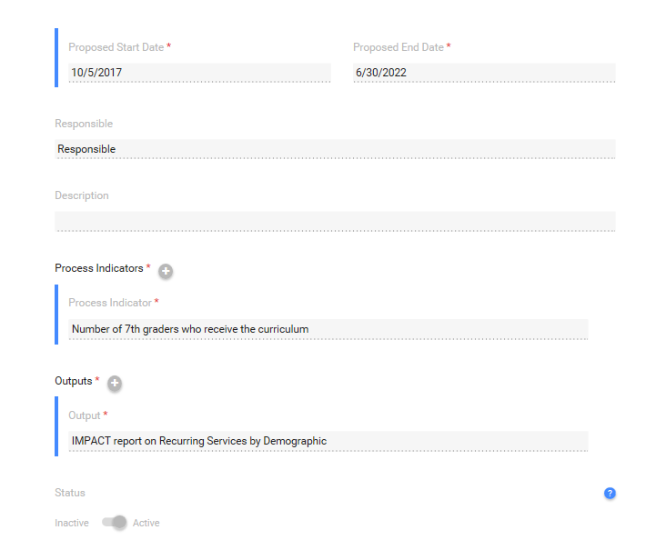

Identify Participants
You may skip over this field for MUNICIPAL PREVENTION TASK FORCES.
There are two ways to report participants; individually or as a group summary. You MUST report participants for MUNICIPAL PREVENTION TASK FORCES but you will have discretion as to the best way to capture that information. Most reporting requires demographic data, but summary level data provides sufficient information for Block Grant reporting. It is recommended that you identify participants at the summary group (vs. individual) level. Doing so will also help to reduce data entry burden. Entering participants at the summary level enables you to skip over the Identify Participants drop-down located under the Planning module.

Identify Groups
This is a required field for MUNICIPAL PREVENTION TASK FORCES.

There are two ways to create groups: participant groups and summary groups.
Participant groups are created from individual participants. We do not recommend using participant groups.

Summary groups can be created from a number of different sources including school enrollment data, classroom or workshop attendance sheets, census data etc.. Summary groups reflect your “estimated target population” or the number of individuals you hope to reach with your prevention interventions.

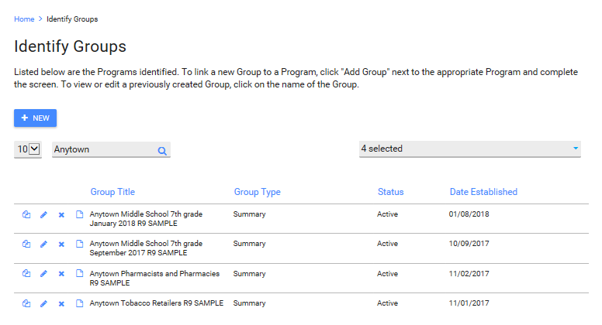

Summary Groups

The Identify Groups screen is quite lengthy and it will be covered over multiple screen shots.

- All fields associated with Identify Groups are required.
- It is recommended that the group title reflect the name of the program and reflect the guidance on naming conventions from page 3 and should also be anchored in a timeframe when the group is likely active, for example a school academic year. This will make it easier to manage data and to know when to change the group status from active to completed.

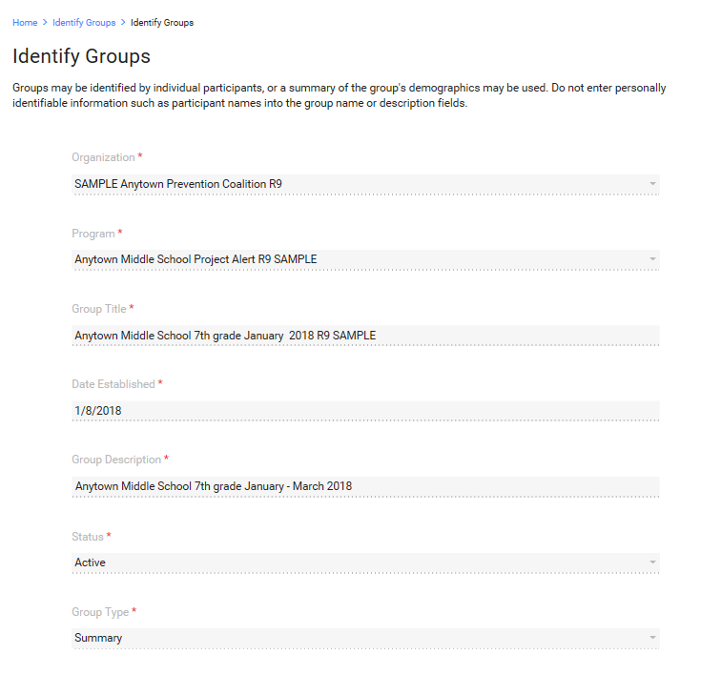
Screen shot continued next page.
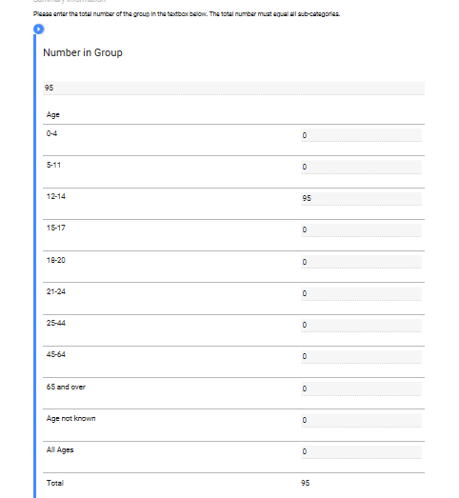

This screen shot covers two fields: Number in group and Age. All totals for different demographic categories MUST add up to the number in group. This example has 5. If ages aren’t specifically known, estimate to the best of your ability. If you really can’t guess, “Age not known” is acceptable

Screen shot continued next page.
(This is a continuation of the screen shot from the prior page.)

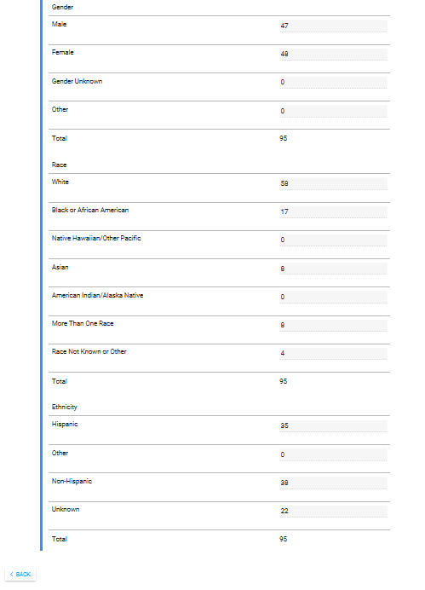
The screen shot on the prior page depicts the remaining categories of gender, race and ethnicity.
- As was true of the other screen, the totals within each of these categories must add up to the total Number in Group category
- Groups should be marked complete at the end of their cycle. Groups can be copied and saved and renamed with a naming convention that reflects the new cycle. Change the status to active and update the demographics.

Manage Logic Model
This is NOT a required screen for MUNICIPAL PREVENTION TASK FORCES.

However, if you a municipal logic model, you would enter it here following the instructions below. No screen shot is provided because this is not a required field.

- Enter your logic model title consistent with the naming convention on page 3.
- The next screen shot will provide additional detail.
- This is the expanded screen for manage logic model. All fields are required and you must upload your logic model as an individual file.
- Don’t forget to use the upload button initially, verify that the upload was successful and then use the save button (not visible in this screen).
- Both the upload button and save button will be blue when they can be selected and both must be used to ensure that the upload take place AND has been saved.

Work Plan
This is a required section for MUNICIPAL PREVENTION TASK FORCES.

- Make a copy of each year of your workplan/task and timeline.
- Upload each individually; you can delete old versions and update with newer ones.
- When the timeframe for the task and timeline has passed, change it to inactive status.
- The next set of screen shots provide more detail on work plan entries.
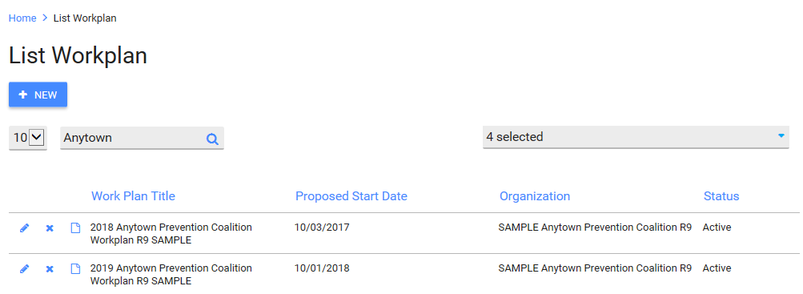
This is a Sample Entry for current work plan year.

- Please be sure to identify the year/time frame associated with the work plan.
- You can specify the range of time covered by the Task and Timeline uploaded by using the dates in the “Description Section.”
- This is not displayed in the screen shot but you must use a two-step process; first upload, and then, save.
- If you don’t hit the save button at the end, it will not save.

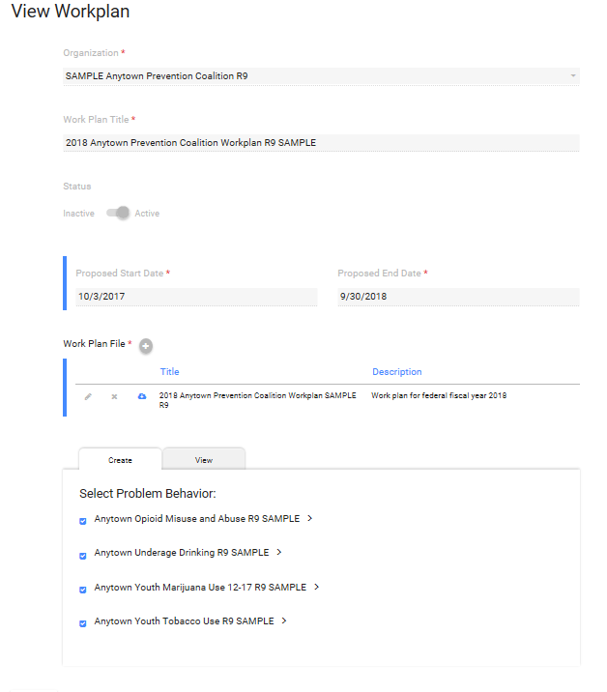

Section 4 – Implement

Each program and activity described in Section 3/Module 3 Planning will be further expanded here in Implement. For program or activity listed, you must have entered either a Single Service or a Recurring Service. See the IMPACT^{SAPT} User Guide Version 1 for additional definitions.

Single services are usually associated with a capacity building type of activity such an assembly, a kick off or launch event, training, distribution of brochures and pamphlets at a school open house, or something is creating readiness for or building capacity to implement an evidence based practice proposed in your MUNICIPAL PREVENTION TASK FORCES strategic plan and logic model. As a general rule, single services are not meant to change behavior but to raise awareness of substance abuse and the role of the coalition in preventing substance abuse and associated problem behaviors.

Recurring services are usually evidence based practices that are either multi-session or multi-component, such as multiple sessions of Positive Action or Above the Influence which has multiple components such as recruitment of youth, creation/adaptation of messages by youth, message testing, use of print or moving images, evaluation of reach and impact. Enforcement strategies would also be considered recurring services. Although activities such as compliance checks and party patrols are typically conducted at different locations, they are still addressing the same target population or individuals living within the same zip code.

See screen shots on the following pages to depict an entry for each type of service.

Record Single Service
This is a required field for MUNICIPAL PREVENTION TASK FORCES.
All single services will be listed and can be selected as active or inactive.

Single Service Description

The description consists of multiple components. This is a screen shot covering the link to the organization, program title (e.g., this is a capacity building effort linked to implementation of Positive Action), start and end date for the PROGRAM (not the single service), the activity and the title.

See the next screen shot for additional information.

(This is a continuation of the prior screen shot)

The objective is linked to the program.

The service type code is established when the program is created. The service population is selected from an extensive drop down menu.

The next screen shot will provide information on the demographic and non-demographic data associated with the single service.

(This is a continuation of the prior screen shot).

You will need to capture the total number of attendees to the single service. The next series of screenshot will include various demographic data. With respect to age, depicted here, you must enter a number that is equal to the total number of participants. It can be age not known, as demonstrated here if the age of the participants is unknown.

(This is a continuation of the prior screen shot).

For each demographic category, the total number must add up to the total number of participants. Each category has some version of “not known” available.
Non-demographic information will be displayed in the next screen shot.
(This is a continuation of the prior screen shot).

Record Recurring Service
This is a required field for PFS.
NOTE: This section has components which appear as tabs; first tab is Service Set up where the service is described; and the second table is Events where more details are provided. Both are required for MUNICIPAL PREVENTION TASK FORCES recurring service entries.

In this screen, you identify the recurring service and a group associated with it.

Service Set Up – Part I

This screen depicts Part I of the recurring service – Service Set Up

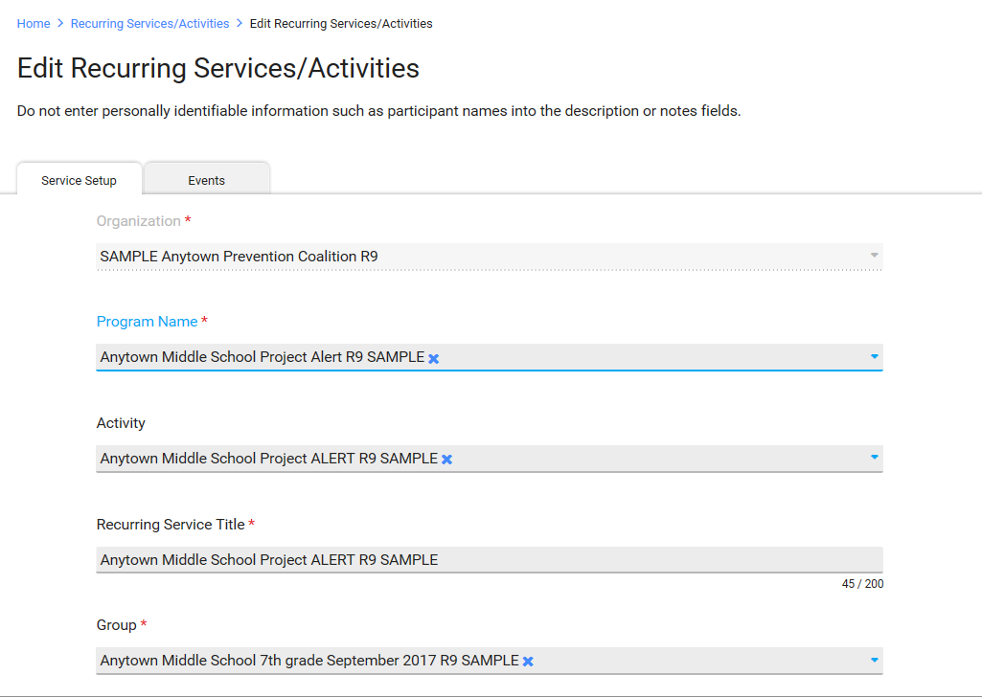

Event Data – Part II

This is the second required screen for recurring services.

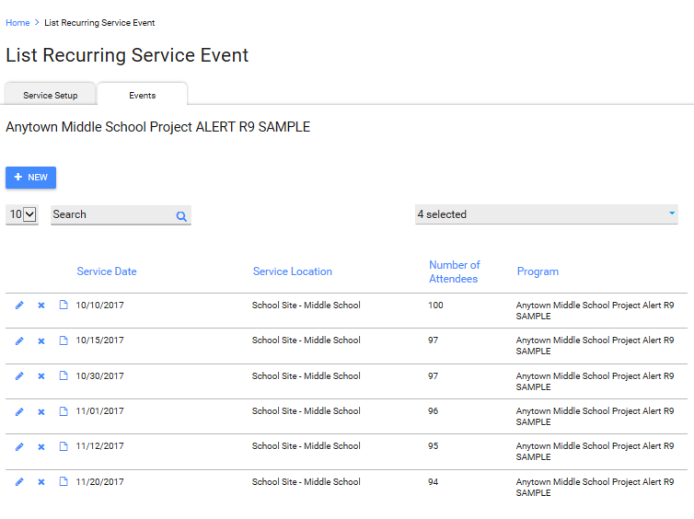
The next page will depict the event detail. This is where the number of participants is captured. This is also where staff time can be captured.

Indirect time would be any kind of time spent in planning or preparing for the event. For example, for a task force meeting you must create an agenda, email or mail the agenda to task force membership and Secretary of State, make copies, travel to the meeting location – this would be captured in indirect time.

Direct time would the actual delivery of or attendance at the event.

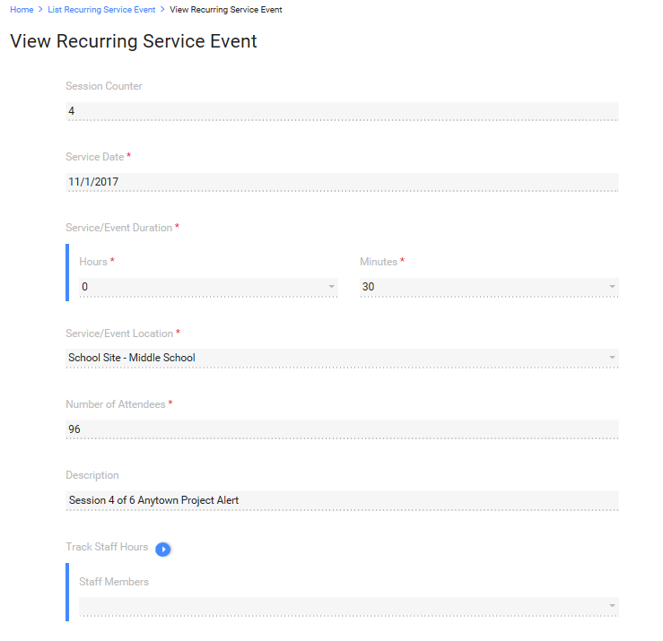

Section 5 – Reporting

IMPACT^{SAPT} will enable you to generate 1) non-demographic reports for enforcement strategies (e.g. compliance checks, party patrols) and 2) demographic reports for prevention education programs and alternative drug free activities (e.g. Positive Action, Asset Champions etc.).

NOTE: IMPACT^{SAPT} does not generate demographic reports for enforcement strategies because demographics for those types of strategies are based on estimates rather than direct counts of individuals.

Planned Activities by Program

Non-Demographic Report:

Report Name: “Recurring Services by Program/Activity”
Purpose: This report will provide you with the total number of compliance checks or party patrols completed within a given timeframe.
In order for the report to generate the information you need, you must first insure that you have entered your data into IMPACT^{SAPT} correctly.

Initial Entry Method:
Compliance checks and party patrols are entered as “Recurring Services” (although these activities are being conducted at different locations, they are still being delivered to the same target population, youth 12-17 living in the community).
Once you have completed the Program setup (as described earlier in this guide), you will need to create a recurring group. [GO TO NEXT PAGE]

- Go to: Plan/Identify Recurring Groups and enter the data using the following conventions:

- basis. Record the total number of compliance checks (or party patrols) under Number of Attendees (this is a field that will show up during reporting).

Generating the Report:
- Go to: Reports/ Reports Module and under Implementation, select Recurring Services by Program.
- Enter start and end dates that align with your reporting period (e.g. April 1, 2016 – September 30, 2016).
- Select your Organization, Program, and Group accordingly and click Generate Report.

- Once you generate your report, it should look similar to the example below. The following report indicates that 84 compliance checks (# of Attendees) were completed as of 8/14/2016 (Service Date). Notice only one page of data was generated. Multiple events will produce more than one page of data. If you have one than one page of data, you will need to manually add up the total number of compliance checks for each page to determine how many were completed within the reporting period. The same applies for party patrols.

Demographic Reports:

Two different types of demographic reports can be generated to capture demographic information for those reached by direct service strategies such as prevention education and alternative drug free activities.

Report #1: “Recurring Services by Demographics”

Purpose: This report will be useful for reporting the total number of individuals reached by interventions delivered to the same group of people over multiple weeks or months (e.g. Positive Action or other school-based curricula)

Generating the Report:

- Go to: Reports/ Reports Module and under Implementation, select Recurring Services by Demographics.
- Enter start and end dates that align with the reporting period sought. Depending upon the purpose of report, it may be monthly, quarterly or annually. Selecting the fiscal year will enable you to determine which groups have carried over from the previous reporting period and which are new during the second half of the fiscal year (as of April 1).

NOTE: When you create a “recurring group” under the Plan tab, you should specify the timeframe (months/years) in which the group will be active under the Group Title.

- Click Generate Report. Once you generate your report, it should look similar to the example below.

Report #2: “Single Services by Demographics”

Purpose: This report will be useful for reporting the total number of individuals reached by interventions delivered to a different group of people each time it is implemented (e.g. parent workshops).

Generating the Report:

- Go to: Reports/ Reports Module and under Implementation, select Single Services by Demographics.
- Enter start and end dates that align with the timeframe for the reporting period.
- Click Generate Report.

Section 6 – Frequently Asked Questions (FAQ’s)

MOSAIX IMPACT^{SAPT}

Q: Where do facilitator trainings for prevention education activities get entered in the Mosaix?

A: Trainings of teachers and administrative staff get entered under Capacity Tab > Training & Technical Assistance.

Q: Where do communities report pre/post measures related to prevention education programs?

Under the Planning Tab > Identify Objectives > “Objective Outcomes” – enter a second line item that specifics use of pre/post measures.

Q: How should communities enter enforcement strategies (compliance checks, party patrols) in Mosaix?

A: Compliance checks/party patrols should be entered as a recurring service. Although compliance checks/party patrols are often conducted at different locations, they are entered as a recurring service because they are still addressing the same target population (12-17 years olds in the community or specific zip codes).

Under Service Setup/Recurring Service Title, enter: “MUNICIPAL PREVENTION TASK FORCES [Community Name] Compliance Checks or Party Patrol [Reporting Period]” (e.g. “MUNICIPAL PREVENTION TASK FORCES Providence Compliance Checks April 1 2016-Sep 20 2016”). Once the Service Setup is filled out accordingly, “Events” should then be added every time you want to enter completed compliance checks. You do not need to enter a separate event for each compliance check. Instead, you will enter summary data (i.e. total number of compliance checks completed):

For example, let’s assume that your community completed 20 compliance checks in May 2016. It is now August and you’d like to update Mosaix to reflect your May activities. Add a new “Event” in Mosaix. Under “Service Date” enter today’s date (i.e. that date you are entering your data). Under “Service/Event Duration” enter 1 hour (this number is arbitrary). Under “Number of Attendees” enter the total number of compliance checks completed.

MEDIA ACTIVITIES TO BE ENTERED AS A ’LOCAL’ MEDIA PROGRAM – RECURRING SERVICES

Please enter media activities with the following characteristics as a “Local” Media Program in IMPACT^{SAPT}:

- The media activity uses a consistent message that is delivered at least 3 times to the same target population (e.g. youth 12-17, parents of youth 12-17, whole community) no matter what channel (social media, coalition website, print media such as paper, parent or community newsletters)
- The media activity/message is focused on changing a specific risk or protective factor contained in your implementation grid or plan (RISAPA, Marijuana and Other Drug Initiative) or Strategic Plan (Regional Prevention Task Forces) such as perception of risk or harm, ease of access or availability, social norms or parental monitoring/family management practices.

Entry method:

- The media activities will then need to be entered as: “(Funding stream and name of community) Local Media Program” in the Plan Module/Program
- Select “Local” for the type of Program
- Create an Activity Entry “{Name of Funding Stream and Community} Media Activity” - the word activity is the change to the naming convention above (see naming convention guidance page 3.)
- Set up each media activity as a recurring service (Service Set Up + Events)
- Each media activity will have separate events within the recurring service

OTHER ACTIVITIES – ‘LOCAL’ CAPACITY BUILDING PROGRAM – SINGLE SERVICE

Media that is designed to raise awareness of the work of the coalition or general messages to create awareness of substance use related problems (but don’t directly address risk or protective factors in your logic model or strategic plan ) should also be captured but will be treated as capacity building or mobilization efforts.

Entry method:

- The media activities will then need to be entered as: “{Name of Funding Stream and Community} Local Media Capacity Building” in the Plan Module>Program
- Select Local for the type of Program
- Record Program Goal as “Raise awareness or visibility of coalition.”
- Create an Activity Entry “{Name of Funding Stream and Community} Capacity Building”
- Set up the media activity as a single service
- Each media activity will be a separate single service

Q. Where do we capture performance measures related to increasing reach or dose of an evidence based practice in IMPACT per the MUNICIPAL PREVENTION TASK FORCES Scope of Work

A: You will need to create an Activity entry in IMPACT that will identify which EBP will have the 10% increase in reach or dose. For example, you may choose to increase Lead & Seed Activities by 10% and the IMPACT entry Programs (Lead & Seed). Activities entry will look like this "Create and implement one additional Lead & Seed activity between September 2016 and May 2017." An entry for increased reach would be a follows "Deliver Life Skills Training to one additional classroom between September 2016 and June 2017."

Additional Instructions & Closing

Once the first round of data entry is complete, the burden associated with entry will be dramatically reduced. There will be continued entry primarily in the Capacity, Plan and Implement Modules. For the Capacity Module: Update Organization meeting will need updating after each coalition meeting as will Update Organization Subcommittee if applicable. For the Plan Module–summary groups after cycles are completed and started and with Workplan which may be modified as your annual task and timelines for the remaining years of the MUNICIPAL PREVENTION TASK FORCES award are modified. For the Implement module – adding and closing single and recurring services for each cycle of the contract award.

Maintenance

You will also need to pay attention to routine maintenance as well – once services are completed, they will need to be changed to inactive. It is recommended that you build in a “service status” review at least quarterly to make sure the single or recurring services that have taken place are switched to inactive status once completed. Once a year, you will need to do the same for the work plan.

Please note that an environmental MEDIA strategy message must a) address a risk or protective factor from the either the REGIONAL strategic plan or MUNICIPAL Work Plan; b) have a consistent message that is delivered to the same target population at least three times by one or more communication channels; and, c) describe the desired change in behavior or policy. All other use of media, such as a website or social media (such as Facebook, Instagram, Snapchat) to raise awareness of problems, mobilize community partners/stakeholders or increase visibility/recognition of the task force/coalition’s work, is considered a local program. See FAQ’s at the end of this document about how to create local media entries.

