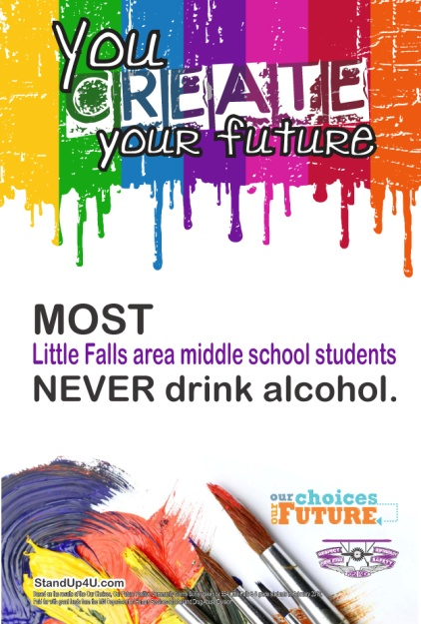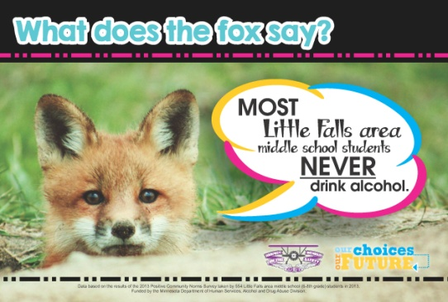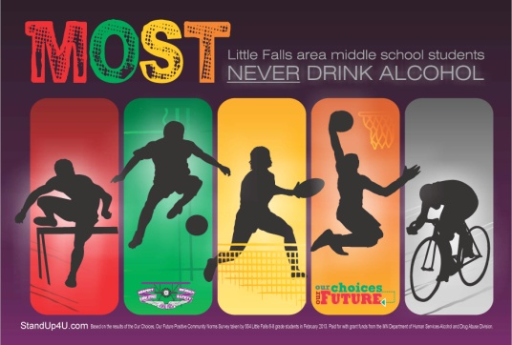
Dear Middle School Teachers and Staff,
Over the next few months, you’ll be seeing these posters throughout the school. Hopefully, they generate some conversations among students and staff as we try to shift the perception of acceptance of alcohol use during the teen years and help students stay focused on being successful and reaching their goals.
How do positive messages change behavior? By now, you may be wondering why we are focused on positive messages. The data from Little Falls students show a gap between what the majority of students are actually doing and their perception of what students are doing. Students (and adults) often behave based on what they think is “normal” within their peer group. If engagining in a risky behavior is perceived as “normal”, students are more apt to engage in that behavior. The same is true if healthy behaviors are perceived as “normal”. In fact, the results of the 2013 Positive Community Norms student survey, taken by Little Falls Students and the other grant communities in the State implementing this same project, found that students who agreed with the statement: “Drinking alcohol is never a good thing for anyone my age to do” were 14 times less likely to drink monthly than students who did NOT agree with the statement. Students who perceived MOST students don’t drink monthly or more often were 5 times less likely to drink monthly than students who perceived MOST students drink monthly more often. We use positive messages to promote the behavior we want to see in all students and correct misperceptions of norms.
When we couple these campaign messages with the Project Northland curriculum implemented in grades 6, 7, and 8, we are able to strike a balance between hope and concern. We see hope because we know the majority of students are currently choosing not to use alcohol and drugs, yet we are concerned because all students are at risk. The curriculum addresses this concern, giving students the knowledge to understand the dangers of substance use and skills to resist peer pressure. Thanks to all the teachers who are implementing the curriculum each year.
The power of the “Our Choices, Our Future” campaign is not the posters, billboards or news ads themselves. The power is in the conversations that these pieces provoke and inspire. There will be extra posters if you’d like to hang in your classrooms or office. As you hear conversations about the messages, please let me know what you’re hearing. The feedback helps us do better and better each time!
Thank you for all you do for the youth in our community. Wishing you a Happy Thanksgiving!
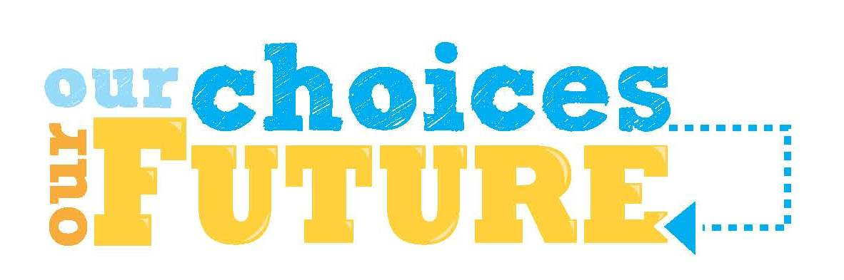
Ann March, Coordinator-LF Youth Substance Use Prevention Project

