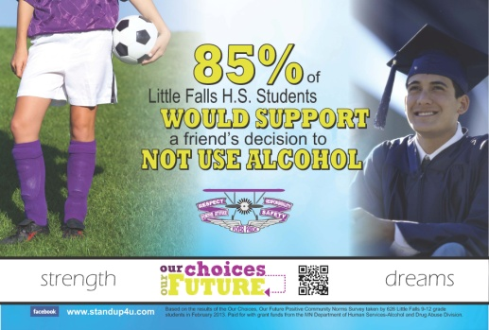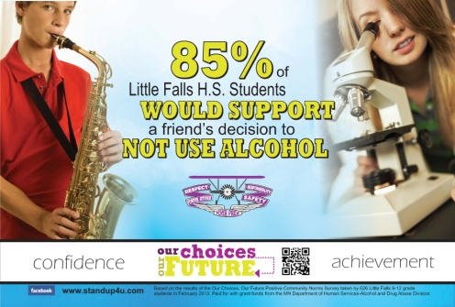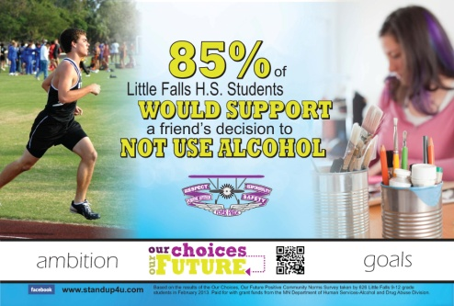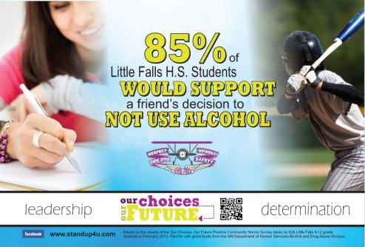

Dear High School Teachers and Staff,
For the last few weeks of the school year, you’ll be seeing these posters throughout the school. Hopefully, they generate some conversations among students and staff as we try to shift the perception of acceptance of alcohol use during the teen years, encourage students to support one another’s decision not to use alcohol, and help students stay focused on being successful and reaching their goals.
We know that students may challenge the believability of the message in the posters because the data show that while most high school students report they would support a friend’s decision not to use alcohol, they don’t believe most of their peers feel the same way. Usually, students will the question the validity of the data and suggest all students lie on surveys. I wanted to give you some background information on self-reported data so if you hear these questions, you can help steer the conversation. There has been a lot of research on the validity of self-reported data. It has been found that self-reported data are accurate when individuals understand the questions and there is a sense of anonymity and little fear of reprisal. No survey is perfect, but overall the results give us an accurate indication of what is occuring. We take every measure to ensure we use the best methods for data collection to ensure acuracy and validity of our data. Here are some ideas on ways to respond to these questions:
- Some students may not take the survey seriously, but most students are honest. The survey was anonymous so there was no reason to dishonest.
- What makes you think that…?.(insert whatever the student is questioning)
- What would our school/community look like if MOST students were using drugs and alcohol? Is that reality?
- What could be changed to make the poster/media piece more believable?
The power of the “Our Choices, Our Future” campaign is not the posters, billboards or news ads themselves. The power is in the conversations that these pieces provoke and inspire. There will be extra posters in the Teacher’s Lounge if you’d like to hang some in your classroom. As you hear conversations about the messages, please let me know what you’re hearing. The feedback helps us do better and better each time!
Thank you for all you do for the youth in our community. Wishing you an enjoyable and relaxing summer!
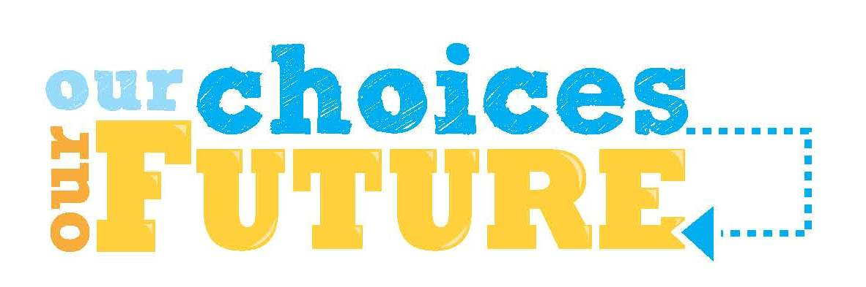
Signature

