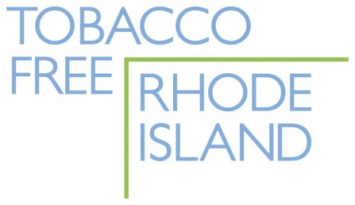
RENEW YOUR ANNUAL MEMBERSHIP IN TOBACCO FREE RI!
Tobacco Free RI is YOUR statewide network: 50+ organizations and hundreds of individuals working together to reduce tobacco use in our communities and statewide.
To help make the 2015-16 year a success, please renew your commitment to the Network. Annual membership of the Network has always been free, but with grant funding shrinking TFRI must become less grant-dependent and more self-reliant. Your financial support will start us down this path to a sustainable long-term future.
YES! Please renew your annual organizational membership and commitment to Tobacco Free RI.
Today’s Date __________________________________

Name ____________________________________ Title ________________________________

Organization _______________________________________________________________________

Address ____________________________________________________________________________

Phone ________________________________ Website ___________________________________

Email _____________________________________________ Yes, add me to your email list.

Is your organization on Facebook? Yes No How about Twitter? Yes No

$250 Corporate Member
$100 Large Nonprofit Member
$50 Small Nonprofit Member
Other Amount $_____________________
We cannot give at this time, but we want to remain a Member of TFRI

Check payable to “American Lung Association of the Northeast”
with TFRI in the memo line. THANK YOU!!

Mail to: American Lung Association of the Northeast, Attn: TFRI
260 West Exchange Street Suite 102B, Providence, RI 02903

